The Original  B.A.T.I.  Training |  | Outlaw Motorcycle Gang Class Hosted by Garfield Sheriff Department in Colorado
February 15, 2022 | Volume 1, Number 1
 |  | 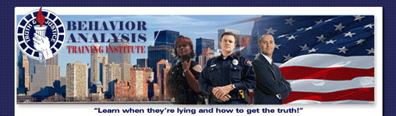  Behavioral Analysis Training  August 17, 2022 0800-1700  Garfield Sheriff-Rifle Range, Rifle Colorado  106 County Road 333A, Rifle, CO  Outlaw Motorcycle Gangs & The Biker Culture  Course Description:  This course is for every law enforcement officer or investigator who wishes to increase their expertise or get up to date in Outlaw Motorcycle Gangs. This class is designed to enhance the officers’ knowledge and safety when coming in contact and investigating members of Outlaw Motorcycle Gangs. This is an 8 Hour Class.  Topics include:  •Brief History of Motorcycle Clubs and Outlaw Motorcycle gangs  •Club Patches and Meanings  •Motorcycle Clubs in California  •Hells Angels – History, Conflicts and Updates  •Hells Angels & Bandidos Connection  •Vagos - History & Updates  •Mongols - History & Updates  *Pagans MC Alliance  •Current Trends  •The 1% Mindset within the Biker Culture  •Infiltrating Mainstream Society  •Developing a Source  *Malos Hechos RICO Case  *Savage Assassins MC  *Infiltration in The Military  *Infiltration into Mainstream Society  •Officer Safety  •Traffic Stops  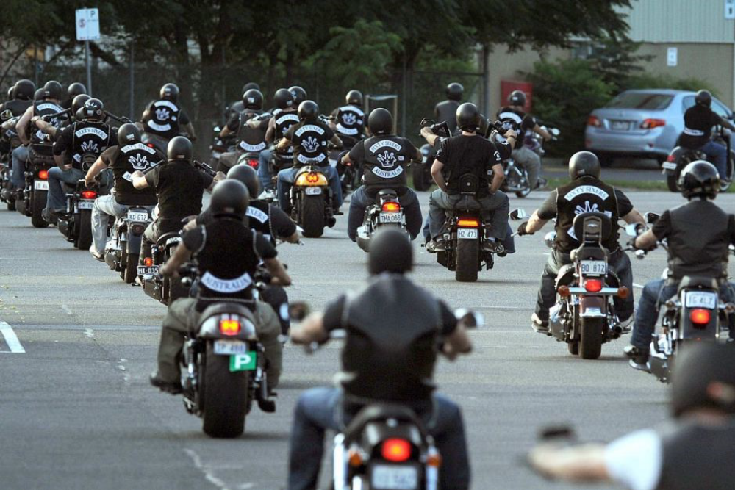  Instructor: Rudy Negron is a retired (2018) Police Officer from the Garden Grove Police Department with 28 years of Law Enforcement experience. Rudy worked outlaw motorcycle gang intelligence for 14 years and participated in multiple outlaw motorcycle gang investigations and takedowns. Recently Rudy provided training in Sturgis, South Dakota prior to the annual STURGIS BIKE RALLY. His other assignments included Field Training Officer, Assistant Reserve Officer Coordinator, Bicycle Patrol, Mental Health Team, State P.O.S.T. Certified Trainer. Tuition: $100.00  IMPORTANT: Due to the sensitive nature and confidentiality of the course, any attendee must have department ID's at the door.  Register online: www.LieDetection.com  Behavior Analysis Training, Inc.  P.O Box 5168  Auburn, CA 95604  Phone: 530-432-0283  Email: liedetection@comcast.net
  “Recipient of the CA Governor’s Award for Excellence in Peace Officer Training”
  